ISYE 6501, Week 9 HW

**Question 1**

Describe a situation or problem from your job, everyday life, current events, etc., for which a design of experiments approach would be appropriate.

**Response –**

In petroleum industry, use of different catalysts at different concentration levels produce various products that are used in the production of plastics and parrafins. Design of experiments approach can be used to see which catalyst has most influence on quantity and the characteristics of the output products.

**Question 2**

To determine the value of 10 different yes/no features to the market value of a house (large yard, solar roof, etc.), a real estate agent plans to survey 50 potential buyers, showing a fictitious house with different combinations of features. To reduce the survey size, the agent wants to show just 16 fictitious houses. Use R’s FrF2 function (in the FrF2 package) to find a fractional factorial design for this experiment: what set of features should each of the 16 fictitious houses? Note: the output of FrF2 is “1” (include) or “-1” (don’t include) for each feature.

**Response –**

The following 10 factors are considered for the fractional factorial design-

1. Location
2. Age
3. Number of Beds
4. Yard size
5. Upgrades (if any)
6. House condition
7. Area
8. Neighborhood
9. School District
10. Garage

The resultant matrix for 16 fictitious houses with “1” for include and “-1” for don’t include is as follows

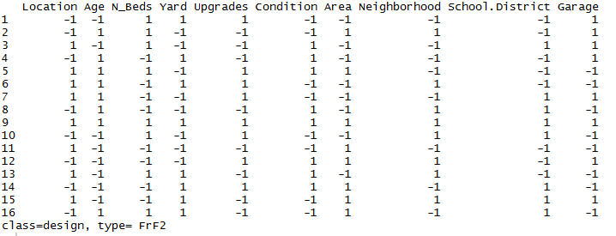

**Question 3**

For each of the following distributions, give an example of data that you would expect to follow this distribution (besides the examples already discussed in class).

a. Binomial

b. Geometric

c. Poisson

d. Exponential

e. Weibull

**Response –**

1. Binomial – In manufacturing industry, the number of faulty items in a batch of products will follow a binomial distribution
2. Geometric – The number of times a dice is rolled and not getting the desired outcome follows a geometric distribution
3. Poisson – Number of vehicles arriving at a traffic signal within a specific time period follows a poisson distribution
4. Exponential – The life of a battery typically can be represented as an exponential distribution when measuring the probability of a battery dying over time
5. Weibull – The duration that a machinery takes to fail when the failure rate is proportional to a power of time.

**Question 4**

In this problem you, can simulate a simplified airport security system at a busy airport. Passengers arrive according to a Poisson distribution with λ1 = 5 per minute (i.e., mean interarrival rate µ1 = 0.2 minutes) to the ID/boarding-pass check queue, where there are several servers who each have exponential service time with mean rate µ2 = 0.75 minutes. [Hint: model them as one block that has more than one resource.] After that, the passengers are assigned to the shortest of the several personal-check queues, where they go through the personal scanner (time is uniformly distributed between 0.5 minutes and 1 minute). Use the Arena software (PC users) or Python with SimPy (Mac users) to build a simulation of the system, and then vary the number of ID/boarding-pass checkers and personal-check queues to determine how many are needed to keep average wait times below 15 minutes.

**Response –**

The simulation model in Arena is set up as shown in the figures below with 1 ID/boarding-pass check station and 4 personal-check stations.

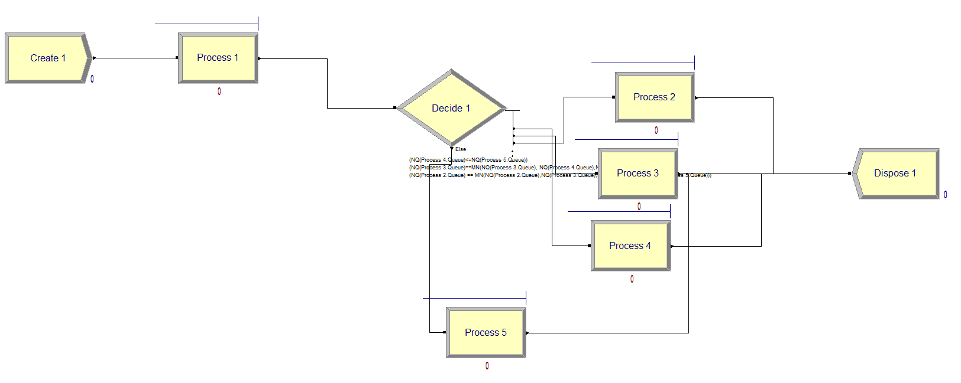

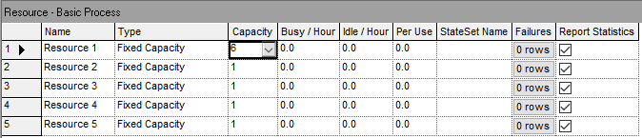

The check stations are set as

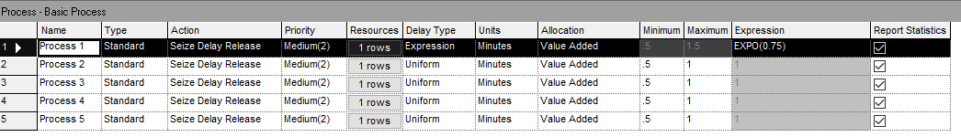

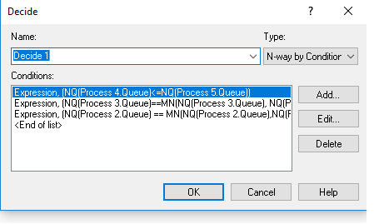

Simulation run is set up as –

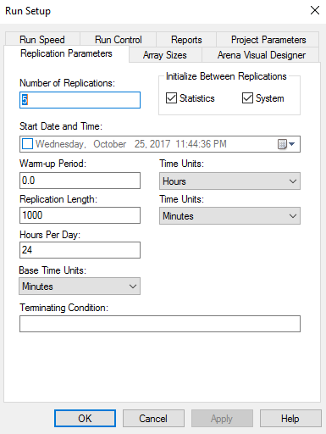

The average wait times are as follows-

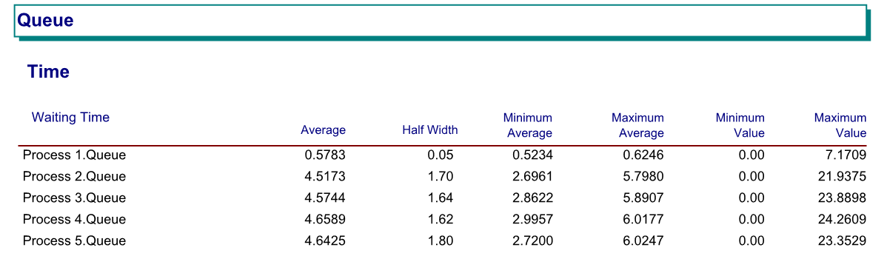

The wait times are not close to 15 minutes but very less than 15 minutes. Further analysis is restricted in the software due to the 150 entity error thrown in the student version. My interpretation is that the current model is using more resources than needed to create a 15 minute wait time since the average wait times are coming out be low.